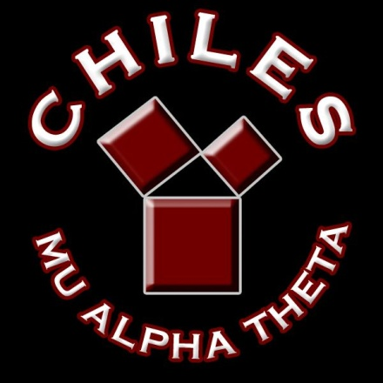**CHILES MU ALPHA THETA**

**2021-2022**

**COMPETITION SCHEDULE**

**TBA FSU Math Competition**

**TBA Rickards Invitational**

**December 11 Chiles Mini Mu**

**January 15 Buchholz Invitational**

**January 29 January Regional (Location TBA)**

**February 12 Lincoln Regional**

**March 5 Dunbar Invitational**

**April 7-10 State Convention @ Orlando**

**July 11-16 National Convention @**

**Washington DC**